Development of an Automatic Generation System for Digital Elevation Models using a Two-dimensional Digital Map

Yong-Cheol Suh¹ Chan-Soo Park² Taewoo Kim²・
1. Dept. of Geoinformatic Engineering, Pukyong National University
2. Dept. of Geoinformatic Engineering, Pukyong National University
* e-mail: suh@pknu.ac.kr

Keywords : DEM, CDT, Ray-Triangle Intersection,

1. Introduction
Recently, the application of BIM (Building Information Modeling) has been actively reviewed and widely used as one of the strategic methods for managing design and construction of large complex facilities including skyscraper, non-programmed and eco-friendly buildings in AEC field (Architect/Civil
Engineering/Construction) all over the world (Choi, 2009). In addition, for the development of construction industry planning, operation and maintenance has become an important consideration for work management.

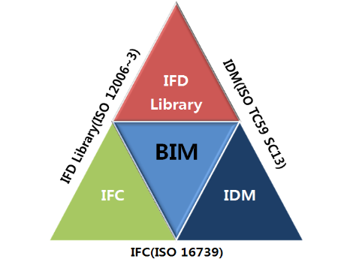
FIGURE-1. BIM Framework of ISO

Table- 1 Nation BIM Standard(USA)
category | definition
BIM Scope | Definition of the step of the building, participants, facilities and elements.
Coverage | Management of the version
Reference Standards | Standardization of documents for compatibility with standards from other organizations and nations
Business Process | Interface on various parts of NBIMS and business process
Business Rules | Definition of the relation between the process and each process
Data Structure and Models | Core elements
Implementation Guidance | Suggest guideline, training and checklist for the application of BIM
Maturity Mode | Definition of the type and amount of information

References
Choi, M. S., 2009. A Preliminary Study on the Strategic Approach for Growth in the Adoption of BIM in KOREA. Proceedings of The Korea Institute of Construction Civil engineering and Management(KICEM) Conference 2009. 598-603.

